**Impact of Data Breach on the organizations-Case study of Marriott Starwood hotel**

**Name of the Student:** Kola Dheeraj

**SRN:** 18021370

**Name of the Organization:** University of Hertfordshire

**Abstract**

In today’s technologically advanced world, data breach has become a major problem. Small companies along with MNCs are also experiencing data breach issues. However, it is tough to state whether such issues can affect customer loyalty. For example, Facebook data breach issue has not changed Facebook users. However, some critics say such issues can hamper organizational performance. This research intends to fine the same by collecting both primary and secondary data.

Table of Contents

1. Introduction 4

1.1 Rationale 6

1.2 Research Aim 6

1.3 Research Objectives 6

1.4 Research Questions 7

2. Background 7

3. Research Methods 9

References 9

# 1. Introduction

The most recent marvel encompassing regular daily existence has spun around information security and protection. An information break is an occurrence of unlawful access/exposure of touchy, secret or in any case secured information (Chatterjee et al., 2019). The centrality of the exploration point is extremely crude regarding progressions in innovation with new programming, equipment for example IoT being created and dispersed monetarily. As indicated by Zhang et al., (2019) there are two kinds of information breaks: deliberate versus unexpected. A deliberate information break incorporates burglary, insider revelation. Though, inadvertent breaks incorporate hacking and infection assaults from outside clients. This task will be founded on the basic examination of past information penetrate and security cases and the effect it has on an association's exhibition. Subsequently, the immense measure of enormous information being created is at a phenomenal rate, information protection and trust between an association and its customers can have extreme effect on an association if their purchaser information isn't safely overseen.

Figure 1 shows the normal exponential development in huge information and the entrance of information has prompted associations expecting to actualize security approaches (Kshetri, 2014). To place that into setting, to spare all the information in 2018, 660 billion Blu-beam circles would be required. A few associations are utilizing information that can be viewed as faulty as far as information assortment and sharing methodology. For example, Android telephones sending data with respect to a client's area (Kshetri, 2014).

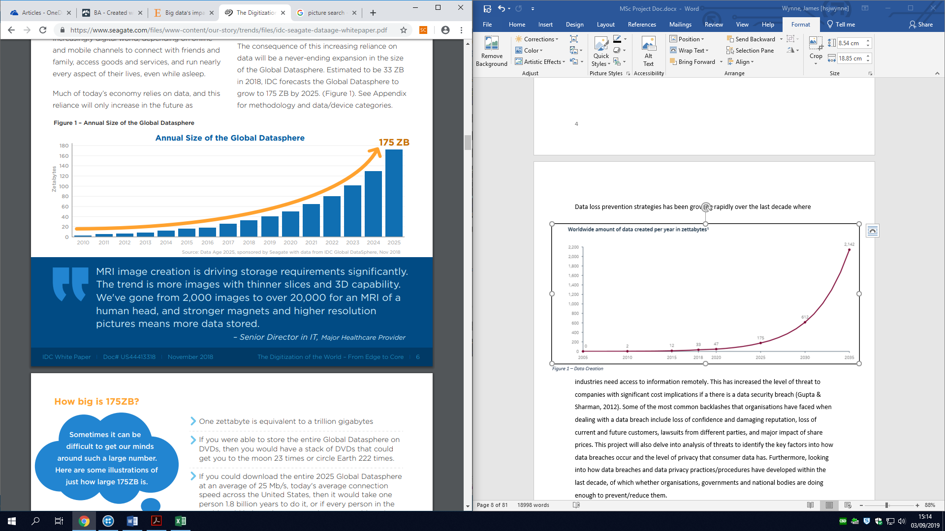Information misfortune counteraction procedures have been becoming quickly in the course of the most recent decade where ventures need access to data distantly. This has expanded the degree of danger to organizations with critical cost suggestions if there is an information security break (Gupta and Sharman, 2012). The absolute most regular kickbacks that associations have confronted when managing an information break incorporate loss of certainty and harming notoriety, loss of current and future clients, claims from various gatherings, and significant effect of offer costs. This venture will likewise dig into examination of dangers to recognize the key elements into how information penetrates happen and the degree of security that purchaser information has. Besides, investigating how information penetrates and information security rehearses/strategies include created inside the most recent decade, of which whether associations, governments, and national bodies are doing what's necessary to forestall/lessen them.

# 1.1 Rationale

An outline of the writing search shows a year on year ascend in distributions in regards to the information penetrate and information protection point inside SCOPUS. Past examination has analyzed the key variables for information penetrates and information protection. Be that as it may, there is an absence of papers demonstrating how every one of these information break factors influence hierarchical execution and what associations need to do to improve their information security. Moreover, investigating how information the executives standards are utilized to alleviate information penetrates and why there should be more set up. This likewise matches with how the GDPR has now come into spot and how it has influenced associations to manage information penetrates.

# 1.2 Research Aim

The primary aim of this research is to find out how issues such as data breach can affect an organization and its performance. For this purpose, this research will focus on one of the biggest data breach cases of recent times- data breach of Marriott Starwood Hotel.

# 1.3 Research Objectives

* To find out reasons of data breach
* To find out impact of data breach on an organization
* To identify to avoid data breach incidents in large companies

# 1.4 Research Questions

1. What are the reasons of data breach?
2. What are the impacts of data breach on an organization?
3. How to avoid data breach incidents in large companies?

* **The population:** Software engineers.
* **The intervention:** Software development team, administration of organizations.
* **The comparison:** Penetration testers, software engineers vs. cybercriminals.
* **The outcomes:** Motivates the organizations by explaining current threats and upcoming growth in cybercrimes.
* **The context:** Rescuing the organizations from cyberattacks by explaining the impact of data breach in organizations (Involving previous record of Marriott Starwood hotel case study).

# 2. Background

An information break contains unapproved access to touchy, ensured, or secret information bringing about the trade off or expected trade off of classification, respectability, and accessibility of the influenced information (Sen and Borle 2015).

Information breaks are influencing all businesses where associations are gathering and putting away information. The most widely recognized information breaks are influencing governments, instructive associations, medical clinics, internet business retailers, etc (Huq, 2015). Thusly, information penetrates in the course of the most recent few decades have been expanding over a quick rate. Especially, in the course of the most recent two years where information breaks in the UK have ascended by 75% (Hurst, 2019). Information penetrates can happen through various directs in associations relying upon an assortment of conditions. For instance, in 2014 Home Depot, a US retailer which works through numerous channels, information penetrate hit their installment frameworks at physical stores (Janakiraman et al., 2018). Interestingly, it is uncommon including each of the associations' various channels being undermined from information penetrate. Thus, an associations' multichannel can be gainful by alleviating negative information penetrate significances by empowering channel migration for buyers that are helpless (Janakiraman et al., 2018).

As indicated by Huq (2015), information breaks are confused in light of the fact that each penetrate has various conditions and factors, this is subject to how an association reacts to an information penetrate. Thusly, when a break is uncovered, the principal convention that should be tended to is; the thing that information/records were taken, the date of penetrate, recognize where and how the assault was entered. Therefore, as per Goode et al (2017), a typical issue that associations face is that the influenced client's relationship with the association will in general separate and they don't buy items or administrations once an information penetrate has occurred. Therefore, France and U.S. advanced associations confronted the biggest client stir when an information break occurs of around 7-8% (Columbus, 2018).

# 

# 3. Research Methods

This research will follow positivism research philosophy and deductive research approach. In terms of data collection, this research will collect both primary and secondary data. In terms of primary data, this research will conduct interviews with managers of Marriott Starwood hotel. A total of 5 telephonic interviews will be conducted. Secondary data would be collected from existing research works, journals, articles and authentic websites.

**References**

Chatterjee, S., Gao, X., Sarkar, S. & Uzmanoglu, C. (2019), "Reacting to the scope of a data breach: The differential role of fear and anger", Journal of Business Research, vol. 101, pp. 183-193.

Columbus, L. (2018). *IBM's 2018 Data Breach Study Shows Why We're In A Zero Trust World Now*. [online] Forbes.com. Available at: https://www.forbes.com/sites/louiscolumbus/2018/07/27/ibms-2018-data-breach-study-shows-why-were-in-a-zero-trust-world-now/#78ca514f68ed [Accessed 17 Aug. 2019].

Goode, S., Hoehle, H., Venkatesh, V. and Brown, S. (2017). User Compensation as a Data Breach Recovery Action: An Investigation of the Sony PlayStation Network Breach. *MIS Quarterly*, 41(3), pp.703-727.

Gupta, M & Sharman, R. (2012) Determinants of Data Breaches: A Categorization-Based Empirical Investigation, Journal of Applied Security Research, vol.7(3), pp. 375-395,

Huq, N. (2015), "Follow the data: Dissecting data breaches and debunking myths", *Trend-Micro Research Paper*.

Hurst, A. (2019). *Data breach reports see 75% increase in last two years - Information Age*. [online] Information Age. Available at: https://www.information-age.com/data-breach-reports-increase-last-two-years-123474521/ [Accessed 17 Aug. 2019].

Janakiraman, R., Lim, J. and Rishika, R. (2018). The Effect of a Data Breach Announcement on Customer Behavior: Evidence from a Multichannel Retailer. *Journal of Marketing*, 82(2), pp.85-105.

Kshetri, N. (2014), "Big data's impact on privacy, security and consumer welfare", Telecommunications Policy, vol. 38, no. 11, pp. 1134-1145.

Sen, R. & Borle, S. (2015), "Estimating the Contextual Risk of Data Breach: An Empirical Approach", Journal of Management Information Systems, vol. 32, no. 2, pp. 314-341.

Zhang, L., Wei, W. & Hua, N. (2019), "Impact of data breach locality and error management on attitude and engagement", International Journal of Hospitality Management, vol. 78, pp. 159-168.